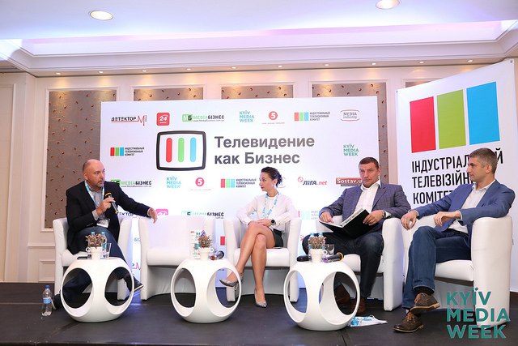
Television as Business conference in the course of KYIV MEDIA WEEK 2017
At the 8th conference Television as Business, held on September 20 in the course of KYIV MEDIA WEEK 2017, the leading media experts discussed the most important issues of the industry, talked about recipes for solving them and shared their experience in implementing media projects. Some of memorable moments of the conference at KMW 2017:
Piracy in Ukraine Is Gaining Momentum
Piracy in Ukraine hasn’t been shrinking; instead, it’s been growing a lot – now it has almost equaled the TV advertising market in size. Such opinion was voiced by Vladyslav Ryashin, general producer at StarMedia, during Summit of Media Leaders panel discussion, which took place during KYIV MEDIA WEEK international forum. It is worth noting that TV advertising market in Ukraine is estimated at 220-250 million USD.
Besides, in the opinion of ICTV director-president Oleksandr Bogutsky, now the control scheme over piracy has been broken. After the Law on Film Production Support was adopted, there was an expectation that fighting piracy will be simplified: say, when a content supplier or producer found their projects on some other website, he/she would only need to send a request for their removal. Then, if the website owner refused to act, the copyrighter could send the letter to the provider, and that organization would block the domain. Now, when since May 2017 State Service of Intellectual Property has ceased its activities, and its authority was instead given to the Ministry of Trade and Economic Development, there is no template of a letter which could be send to the providers in the said circumstances.
Disadvantages of Language Quotas for Foreign Distribution
Due to the government adopting quotas for state language on air of TV stations, the productions are facing some difficulties not simply with creating high-quality content for the minimal funds available at the market but with creating content as such. The thing is, as StarMedia general producer Vladyslav Ryashin explains, that a TV channel produces content in-house, which can be in any language, including Russian, but something made by a production house is considered national, so it cannot be in Russian. Therefore, the TV channel is obliged to dub it. Moreover, if the project has been created in Ukrainian, it – as a finished product, not a format – is harder to sell abroad, because Ukrainian-speaking audience is significantly smaller than Russian-speaking one. Creating project in two languages means increasing the budget by at least one and a half times. And in the end, it might be a project with no returns on investment.
As for the expenses, in the opinion of ICTV director-president Oleksandr Bogutsky, Ukrainian TV channels have to spend at least 30 to 40 thousand USD per episode of the series, which “is still watchable”, and the payback will be only about 10 thousand USD. A sitcom can be broadcast about five times; a drama series, two in most cases. In Russian, the potential for returns is higher because the project can be sold to Russia, CIS countries, and catalogues of Russian VOD services.
“Of course, we are ready to invest between 150 and 200 thousand USD in one episode,” says Ryashin. “Still, in the UK the production costs for one episode of the series are 800 thousand EUR on average.”
All the pictures will be uploaded here: http://bit.ly/Photos_KMW_2017
Texts are here: https://kyivmediaweek.com/en/presskit
The program of the next days of KMW 2017 here

