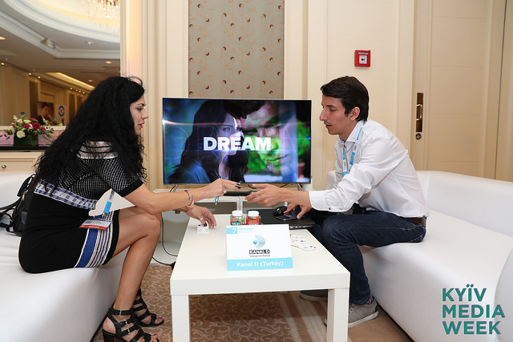
KYIV MEDIA WEEK - most memorable moments of the second day at the 7th international media forum
On the second day, KMW Content Market traditionally started its work. This year, the market vendors represent over 100 countries and buyers, twenty-six.
Other memorable moments from KYIV MEDIA WEEK 2017 second day:

CINEMATOGRAPHIC LITERATURE – TEN FRESH UKRAINIAN NOVELS READY TO BE FILM-ADAPTED
On September 19 in the framework of KIEV MEDIA WEEK 2017 a special report on cinematographic literature from Ukrainian literature scholar and literary critic Tetyana Trofimenko was presented. The event offered a selection of the latest editions in contemporary Ukrainian literature which have a definite screening potential.
This year the list includes a mystical thriller from Max Kidruk Don’t Look Back and Stay Silent, a collection of novellas by Kateryna Kalytko The Land of the Lost Ones, or Little Scary Tales, a dilogy about war by Volodymyr Refeyenko entitled The Longitude of Days, a book by Artem Chapay Dad on Paternity Leave, a novel by Larysa Denysenko Maya and Her Moms, a dystopian novel Pomyrana by Taras Antypovych, an adventure science fiction novel about the war between Ukraine and Russia The Third Front by Vladyslav Ivchenko, a dramatic techno-thriller Look Into My Dreams by Max Kidruk, a novel about Odessa bohemian life Tanzher by Ivan Kozlenko, and also one more novel about war, The Eastern Syndrome by Yulia Ilyukha.
A similar event was held under the aegis of the conference for the second time. Just a reminder: last year the list of promising works included a fairy tale by Kateryna Babkina A Hat and a Whale; an unpublished novel by Vladyslav Ivchenko The Fighters of Invisible Front; an investigative novel by Larysa Denysenko The Echo: From the Perished Grandfather to the Dead One, a thriller by Max Kidruk The Cruel Sky, an adventure novel by Yuriy Vynnychuk The Pharmacist, a biography by Tanya Malyarchuk Oblivion, and a science fiction dystopia by Taras Antypovych The Chronos.

UKRANIAN AND KOREAN MEDIA INDUSTRIES BECOM CLOSER

September 19, in the framework of KYIV MEDIA WEEK international media forum, a Ukrainian-Korean roundtable discussion was held. The last has already become a traditional annual event. This year, representatives of Korean specialized associations, media companies and state institutions together with the officials of Ukrainian National Council on TV and Radio and managers of leading Ukrainian broadcasters and productions got together to discuss bilateral cooperation in all media fields.
In the end of the event, Korea Radio Promotion Association and FILM.UA media group (Ukraine) signed a memorandum of cooperation for production of audiovisual content. Representatives of Korea Radio Promotion Association promised to facilitate and support the launch and production of new joint projects.
Just a reminder: yesterday, on September 18, representatives of Ukrainian animation industry signed a memorandum on cooperation of animation industries with South Korean representatives (Korea Radio Promotion Association and Korea Animation Producers Association).

UKRAINE AND MOLDOVA AGREE ON JOINT FILM PRODUCTION

September 19, the first result of roundtable discussion on production industries in Ukraine and Moldova, which took place during KYIV MEDIA WEEK international media forum, was the conclusion of a memorandum on joint film production between Ukraine and Moldova. The document was signed by Valeriu Jereghi, head of Moldova National Film Center, and his Ukrainian counterpart Pylyp Illenko. It is worth noting that for Moldova which established its film center only last year (thanks to the reform of the country’s current system for film industry state support) this document became the second international cooperation agreement. Just a reminder: a bit earlier, similar document has also been signed between Moldova and Romania. Besides, an agreement on joint production between Moldova and France is currently being prepared.

YOUTUBE AS THE BEST WAY TO MONETIZE VIDEO CONTENT AND THE MAIN COMPETITOR OF TV CHANNELS AND WEBSITES
On Tuesday, September 19, under the aegis of KYIV MEDIA WEEK 2017, a workshop from FILM.UA Faculty (joint education initiative of FILM.UA and Media Resources Management dedicated to various stages of film and TV production) was offered under the following title: “How to make digital content work for you in 2018?”
During the event, there were reports from FILM.UA Group creative producer Anna Eliseeva, Starlight Digital commercial director Mykola Fayengold, Starlight Digital creative director Vitaliy Chyrkov, director of YouTube brand promotion department at AIR Vira Slyvinska, founder of UaMaster agency Yevgen Shevchenko, and Megogo marketing director Ivan Shestakov.
The workshop was mostly dedicated to promoting content via YouTube, different ways to monetize own-produced content, and also prospects of VoD platforms in Ukraine.
The event was opened by Anna Eliseeva who demonstrated a successful FILM.UA case, Back to Basics project which wasn’t only broadcast at Eurovision 2017 but also sold to Amazon. Presently a special TV project is being prepared based on the series of these short videos.
Eliseeva also noted that now YouTube is among the most profitable platforms for monetizing video content; this was also supported by other workshop participants. Olena Slyvinska pointed out that YouTube brings not simply advertising revenues but enables to integrate brands, use sponsorship and product placement, involve partner links, use merchandise, donations and crowdfunding, open auxiliary channels, and also initiate subscription to earn from one’s own content.
In their turn, Starlight Digital representatives shared their own strategy of content monetization. According to Vitaliy Chyrkov, YouTube is the main competitor of own channels and websites, as monetization through one’s own platforms brings much more revenues. That is why Starlight Digital uses the strategy of dividing monetization from Ukrainian and international users; knowing that the biggest hype around a new project is observed within the first 48 hours from the moment of its publication, during this time the company bans access to this content via YouTube for a local user, counting on its own website, and also bans access to channel content for international users, monetizing this audience via YouTube. Vitaliy Chyrkov also announced the company’s intention to enter the Indian market in the nearest future and told about the benefits of using the so-called “second screen” as an interactive instrument for better audience engagement. To do this, the company developed Teleportal, a special app.
Besides, Yevgen Shevchenko presented a successful case of #Oschadbankdiye project, and Ivan Shestakov shared information about the latest successful projects at Megogo, described the platform structure and also noted that subscription is in his opinion the only accessible way to scrape up the budget for producing own content.

UKRAINA TV CHANNEL EXPERIMENTS WITH VERTICAL SERIES PROGRAMMING
During a special event at KYIV MEDIA WEEK 2017 international media forum, “Series. How-to” dedicated to studies of leading world experiences and trends of series production, a report was presented by Ukraina TV channel representative Natalya Strybuk; its title was “National Trends in Producing Vertical Series of Ukraina TV Channel.”
Initially, the speaker singled out an important feature of series content viewing by Ukrainian audience, which is the trend of watching TV as a background activity. According to Ukraina representative, presently the audience is not ready to get immersed in long fabula-type stories envisaging emotional stress and frequently rather traumatic experiences. Due to this, a demand for vertical series emerges, where each new episode contains a totally different story, with familiar characters traveling from one episode to the next – therefore, one can start viewing the series from any episode. Successful examples of such format on Ukraina TV channel are Agents of Justice and Doctor on Call which demonstrated rather high rankings in comparison with prime-time TV novellas.
Besides, due to the popularity of medical and detective settings, Ukraina is going to launch two more similar projects in the nearest suture, The Specials detective series and Doctor Kovalchuk medical drama; 45 episodes of the latter’s first season will be broadcast in early prime-time starting from October 30.
Natalya Strybuk has also noted that the audience has grown more loyal to Ukraine-produced content. If, according to the surveys, in 2007 31 per cent of the population were ready to watch Ukrainian projects, in 2016 the proportion has grown to 55 per cent.

All the pictures will be uploaded here: http://bit.ly/Photos_KMW_2017
Texts are here: https://kyivmediaweek.com/en/presskit
The program of the next days of KMW 2017 here

