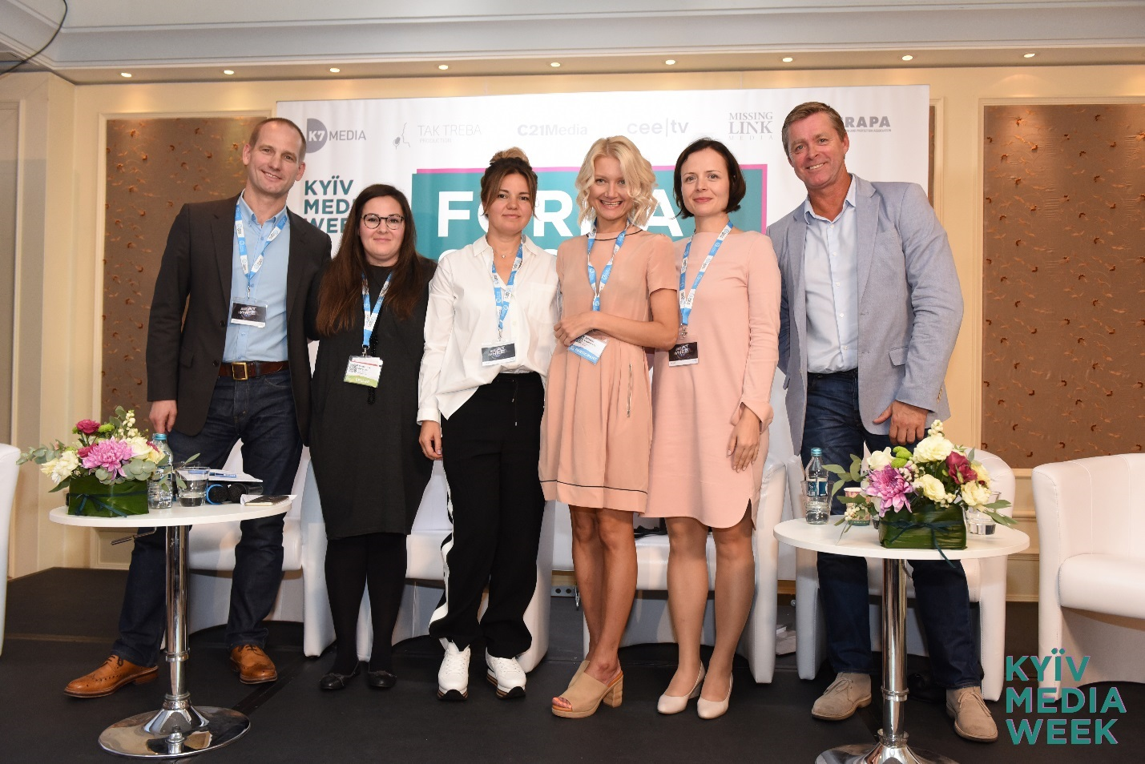
KYIV MEDIA WEEK – the review of the first day!
The 7th edition of international media forum KYIV MEDIA WEEK 2017 has started on September 18. KYIV MEDIA WEEK 2017 (KMW 2017) feature an unprecedented number of events that take place in one place and at the same time.
The highlights of the first day of KYIV MEDIA WEEK 2017 are:
FORMAT SHOW
Ratings of TV-formats. Breakthroughs and failures of 2017
September 18, in the course of the international media forum KYIV MEDIA WEEK 2017, a presentation dedicated to the most significant television formats of 2017 was held.
Georgi R. Chakarov, general director of the Bulgarian company CEETV, spoke about projects, which has been not only often imported but showed really high ratings this year. Among them are such shows as American show-quiz The Wall produced by NBC, British reality First Dates and French game show Guess My Age. However, Chakarov notes the brevity of popularity for some of them, e.g. The Wall.
On the other hand, there are projects created a long time ago, but continue to beat all the records. We can add on to classical shows the one called Sasuke, invented in 1997 in Japan, better known as Ninja Warrior in the international market. Now it is on air with the highest ratings in France, Spain and Australia.
The greatest disappointment of the current year was the show Lost in Time. Considering the complex interactive elements necessary for show, it took about one and a half year to launch it, however, the performance of the premier release was far from desired. According to Chakarov, the main reason is lack of advertising.
How to Invent and Protect a Format
On September 18, during KYIV MEDIA WEEK 2017 international media forum Jan Salling, co-president of FRAPA board and CEO of Missing Link Media (Denmark), delivered a presentation on creating and – what is even more important! – protecting a format from theft. Salling named ten essential steps to be followed:
1) provide a proof that you are the author of the format and be ready to protect your rights to it;
2) write your idea down before showing it to anyone;
3) arrange copyright and/or create a domain dedicated to the project;
4) register your format at FRAPA (this costs between 30 and 50 EUR);
5) create a pilot or a promo;
6) keep your idea secret and share it only with those able to buy it and to implement a project;
7) license your format;
8) sell it to TV channels;
9) make it recognizable abroad – create a workable project Bible to simplify its adaptation abroad;
10) put your heart into the format, present it in a passionate and emotional way. You should also clearly spell out your idea in the promo so that the gist of the project is as comprehensible as possible.

Servant of the People Goes to France, Greece and Korea
The format of Ukrainian comedy series Servant of the People has been sold to Greece, and an option for format, to France. This was announced by Natalya Yakovleva, sales director of Studio Kvartal 95, at FORMAT SHOW international conference which took place on September 18 during KYIV MEDIA WEEK international media forum.
Just a reminder: international distribution for Servant of the People is provided by Eccho Rights (with head office in Sweden). Kvartal 95 press service has clarified that the format of the series was acquired by Star Channel (Greece), and the option for format, by Elephant Story (France), which is a part of Elephant le Group.
The series will also travel as a finished product to South Korea where it will be broadcast on HQ Plus this November. It is rather telling that the Ukrainian comedy will become the first international content for this TV channel.
Servant of the People, with its second season starting on October 23 on 1+1 TV channel, has enjoyed significant popularity among Ukrainian audience and was continued in 2016 as a feature film entitled Servant of the People 2. The first season of the series has become available for international audience on Netflix platform this year.
The protagonist of the series is Vasyl who works as a teacher in a regular Ukrainian school. However, he’s much too eager to leave his trace in history and, unlike most citizens, ready for decisive action. What pains him most is seeing how corruption and impunity reign over the country year in, year out. To change the future, Vasyl decides to run for president.

Ukrainian public broadcaster and China Radio International signed an agreement on cooperation
Today, September 18, in the capital of Ukraine, the international media forum KYIV MEDIA WEEK started with a roundtable discussion on the prospects for development and cooperation of content industries in Ukraine and China.
The event, supported by the National Council of Television and Radio Broadcasting and the Embassy of the People's Republic of China in Ukraine, signed an agreement on cooperation between the National Public Broadcasting Company of Ukraine (UA: PBC) and China Radio International (CRI).
The document was signed by Tian Yuhong, deputy general director of CRI, and Zurab Alasania, the head of the board of UA: PBC. "We start cooperation with the China Radio International with the projects of the Chinese Theater, planning to expand the line of Chinese content maximally later on. We also plan to provide China partners with Ukrainian content", Alasania said.
Valentin Koval, a member the National Council of Television and Radio Broadcasting, said that he hopes that the signing of this agreement will be the beginning not only of cooperation with the National Public Broadcasting Company of Ukraine but also with all television of Ukraine.

It is possible to fight piracy – and to do it successfully and efficiently
In Ukraine, it is now possible to fight video piracy rather efficiently within the limits of current legislation. How to do it and what to pay attention to — these were the issues discussed by business owners, top managers and lawyers of Ukrainian and international companies on September 18 during KYIV MEDIA WEEK 2017 at the conference for copyrighters organized by Clear Sky initiative.
Today, there are ways to fight illegal content published both in Ukraine and abroad, as hosting owners started dynamic cooperation with copyrighters. In its turn, Ukrainian cyber police introduces methods of fighting piracy, providing the newest solution to the copyrighters. The latter, having overcome the psychological barrier of filing the first claim about violation of copyright on the Internet, start protecting their own content in a more active and productive way. Besides, to implement the abovementioned idea in real life one does not need big staff anymore ; there is a unique software working in this field extremely well.
During the conference, the participants were informed about legal procedures of blocking illegal content and the schemes of interaction with the resources violating copyright. Vyacheslav Miyenko, deputy general manager for legal issues at 1+1 Media, is convinced that pirates will always be more flexible than copyrighters. However, it is possible to complicate the pirates’ life in a very significant way. E.g., when a claim is filed for each item separately, the offender will have to pay a penalty for each such item.
FOUR UKRAINIAN FULL-LENGTH DOCUMENTARIES PARTICIPATED IN B2B DOC PITCHING
Projects of several new Ukrainian full-length documentary films were successfully presented at B2B Doc CoProduction Meetings, which took place on September 18 at KYIV MEDIA WEEK 2017.
The international jury composed of Tereza Svadoschowa (representative of Ji.hlava International Documentary Film Festival, Czech Republic), Kristyna Balaban (coordinator of international program at Ex Oriente Film, Czech Republic), Aurelian Niki (producer at Kinetoscop, art director of Buzz CEE international documentary festival, Romania), Carla Pontus Jurtena (Svenska Filmstudion, Sweden), Johann Set (Indio, Sweden), Aleksandar Govendariza (representative of Syndicado sales company, Canada), Anna Ferens (TVP1, Poland) and Kenan Aliev (Current Times TV, Czech Republic) have noted the festival potential of such projects as My Father Is My Mother`S Brother directed by Vadim Ilkov and produced by Darya Bassel (about a Kyiv artist and musician Anatoliy bringing up his sister’s small daughter with special mental needs); Underwater directed by Oksana Kazmina and produced by Yulia Serdykova, about a Kyiv artist Anti Gonna; The Devil directed by Yegor Troyanovsky and produced by Olga Beskhmelnitsyna, about a father looking for his son who left to fight in the eastern Ukraine;and Roses directed by Irena Stetsenko and produced by Denis Vorontsov, about Ukrainian freak cabaret Dakh Daughters.
In particular, Anna Ferens has manifested her interest in the project of Irena Stetsenko and noted its TV distribution potential. Her opinion was seconded by Indio representative Johann Set. The authors of other films received a recommendation from the professional jury to look for distributors after their projects are released at festivals.
Apart from Ukrainian films, there was also a Belarusian project Mein Deutschland directed by Aleksandr Svischenkov about an elderly Russian-speaking German; a Georgian project about a young Stalinist Stalin Today directed and produced by Ketevan Nozadze; Satanic Girls: Women on the Move produced by Anna Kherza Tydlytatova about the reunion of female band after the death of its participant; and also two Armenian projects, Mel produced by Arevik Avanesyan and Deminers directed by Silva Khnkanosyan (about a female group of volunteers searching for active mines after the war in Yugoslavia).
Special attention was given to Mel project; Swedish colleagues immediately proposed their involvement as co-producers.
B2B Doc (Baltic to Black Sea Documentary Network) is an international platform initiated by Swedish cinematographers to develop cooperation among documentary filmmakers in Sweden, Finland, Estonia, Latvia, Lithuania, Belarus, Ukraine, Moldova, Georgia and Armenia. B2B Doc creates a network of contacts among filmmakers to develop and implement joint projects with great international potential. Through workshops, seminars and trainings on pitching for B2B Doc platform participants, it provides support for the development of selected projects, ensuring their participation in competing for financing at the European film production market. Besides, B2B Doc provides financial support for projects at an early stage of development and travel grants for participation in pitchings, festivals and co-production forums.

All the pictures will be uploaded here: http://bit.ly/Photos_KMW_2017
Texts are here: https://kyivmediaweek.com/en/presskit
The program of the next days of KMW 2017 here

